HOL Enzymes: Temperature, pH, and Specificity

Go to the HOL website and look over the lesson material for the enzymes lab. Do the lab and fill out my worksheet below and submit that. It follows my usual convention of data tables, summary and picture.

The enzyme lactase breaks down the disaccharide lactose (glucose + galactose), giving the monosaccharides glucose and galactose as its products. Exercise 1 is meant to demonstrate that lactase will break down lactose (found in milk) and produce glucose, which you detect using glucose test strips. Sucrose (common table sugar) is another disaccharide (glucose + fructose) and should not get broken down. Hopefully, it will not test positive for glucose even after the enzyme has had time to react. A solution of glucose is used as a positive control to verify the glucose test strips work.

Exercise 2 is meant to show that enzymes like lactase work at an optimum temperature and pH. Lactase activity in room-temperature water should be greater than in hot or cold water. There should be some pH where lactase activity is greatest.

Substitutions:

If you are missing essential components from your kit, consider the following:

1. Lactase enzyme tablets (e.g. Lactaid brand) can be used as your source of lactase.

2. Ordinary table sugar is sucrose.

3. Glucose tablets can be purchased from drugstores like CVS and Walgreens.

4. Spring water can substitute for distilled water.

5. Glucose test strips for urine can be purchased from Walmart, Walgreens and CVS but probably only online.

6. Household products have different pH values. Avoid using any (like alcohol or shampoo) that may denature the enzyme. Go with drinks like fruit drinks or orange juice for neutral and acidic conditions. Scratch out the pH I have listed and write in the pH value (found online) for any product you substitute. All you need are liquids that will provide an environment with a different pH but will not damage the enzyme by some mechanism other than pH.

I pasted the complete procedures for this lab below the worksheet in case there are technical difficulties accessing the HOL website.

HOL LACTASE ENZYME WORKSHEET Name:

Table 1. Enzyme Specificity
Test Solution | Strip Color | Glucose Concentration (mmol/L)

Sucrose

Milk

Sucrose + Lactase

Milk + Lactase

Glucose

Table 2. Optimum Temperature of Lactase
 | Glucose Concentration (mmol/L)
Temp. (°C) | 5 min | 10 min | 15 min | 20 min

Cold:

Warm:

Hot:

Table 3. Optimum pH of Lactase
pH | Glucose Concentration (mmol/L)

3.5

5.0

6.8

11.5

Summary of Results:
1. Summarize your results in your own words. If anything did not go as expected then explain what you think caused this to happen.

Picture of You with Your Lab:

Please include a picture of you with your lab setup:

Exercise 1 - Enzyme Specificity
In this exercise, you will determine the ability of lactase to be specific and to catabolize. You will compare the effect of lactase in the breakdown of lactose into glucose and galactose and the breakdown of sucrose into glucose and fructose.

Procedure (Preparing Solutions)
- Use the permanent marker to label 4 plastic cups as follows: 5% sucrose, milk, dH₂O, and lactase.
- Pour the ¼ cup of milk into the cup labeled "milk", and pour approximately ¼ cup of distilled water into the cup labeled "dH₂O". As these are approximate amounts it is not necessary to use the graduated cylinder for this step.
- Use the permanent marker to label the bulb of a clean pipet "milk" and place the labeled pipet in the milk cup. Label a second clean pipet "dH₂O," and place the labeled pipet into the distilled water cup.
- Prepare the lactase solution as follows:
  - Use the graduated cylinder to measure and transfer 150 mL of distilled water into the plastic cup labeled "lactase."
  - Crush the lactase pill in its wrapping by placing the pill on a table and using the bottom of the 250 mL glass beaker to crush the tablet. Be gentle with the beaker, taking care not to break it while performing this step. See Figure 6.
  - Carefully open the wrapping of the crushed tablet and pour it into the "lactase" cup holding 150 mL of distilled water.
  - Use the permanent marker to label the bulb of a clean pipet "lactase" and place the pipet into the lactase cup.
  - Use the lactase pipet to stir the crushed lactase pill and distilled water until dissolved.
Note: It is all right if there is additional crushed pill that does not dissolve into the water.
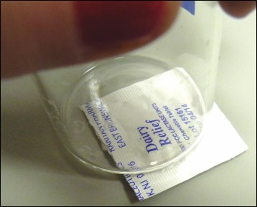 Figure 6. Crushing the lactase tablet.
5. Prepare the 5% sucrose solution as follows:
  - Place the weigh boat onto the digital scale and tare the scale so that it reads 0.00 g.
  - Add sucrose (table sugar) to the weigh boat until scale reads 2.50 g.
  - Carefully pour the sucrose from the weigh boat into the graduated cylinder.
  - Fill the graduated cylinder (to the 50.0 mL mark) with distilled water.
  - Pour the contents of the graduated cylinder into the cup labeled “5% sucrose.”
  - Carefully pour the contents of the cup back into the graduated cylinder and then back into the cup, as needed, to transfer all of the sucrose into the labeled cup.
  - Use the permanent marker to label a clean pipet “5% sucrose” and place the pipet into the cup.
  - Use the pipet to stir the solution until the sucrose is fully dissolved in the distilled water.
6. Place all 4 prepared solutions onto your work surface. See Figure 7.
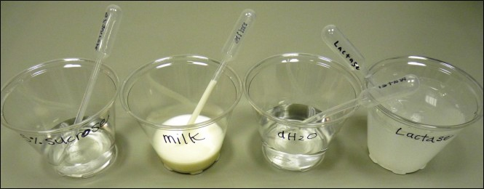Figure 7. Prepared solutions.

Procedure (Preparing Solutions)
- Place a clean piece of paper towel on your work surface.
- Use the permanent marker to label 5 wells of the 24-well plate “A, B, C, D”, and “E.” Then place the labeled well plate on top of the paper towel.
- Gather 5 glucose test strips and use the permanent marker to label the strips “A, B, C, D”, and “E.” Place each glucose strip in front of its corresponding well.
- Use the scissors to cut off the tip of the 20% glucose pipet, and place the pipet bulb-side down (tip side up) in an empty well of the 24-well plate. The well-plate will act as a pipet holder.
- As described in Data Table 1, use the labeled pipets to add solutions to the following wells:
  - In Well A: add 3 drops of 5% sucrose and 3 drops of dH₂O
  - In Well B: add 3 drops of milk and 3 drops of dH₂O
  - In Well C: add 3 drops of 5% sucrose and 3 drops of lactase
  - In Well D: add 3 drops of milk and 3 drops of lactase
  - In Well E: add 3 drops of 20% glucose and 3 drops of dH₂O
Note: Ensure that pipets are only used to transfer solutions from their designated cups.
- Allow each of the reactions to occur for 5 minutes.
- After 5 minutes, pick up the glucose strip labeled “A,” and insert the green end into the reaction in Well A. Allow the strip to remain in the solution for 5 seconds.
- After 5 seconds, remove the strip from the well and place it on the paper towel.
- Use the Glucose Color Chart to determine the amount of glucose (mmol/L) present in the well. Read the test strip 1 minute after removing it from the well.
- Record the amount of glucose present in Data Table 1 under “Glucose Concentration.”
- Repeat steps 13 through 16 for the remaining 4 wells (B, C, D, and E).

Cleanup:
- Discard the used glucose strips in the trash when complete.
- Keep all solutions and other materials to use in the next exercises.

Exercise 2 - Enzymes, Temperature, and pH
In this exercise, you will determine the optimum temperature and pH for catalysis by the lactase enzyme.

Procedure (Sample Prep for Temperature Effects)
- Prepare a boiling water bath:
  - Place the burner fuel on the aluminum pie plate.
  - Place the burner stand in the center of the aluminum pie plate.
  - Fill the 250 mL glass beaker approximately ¾ full with tap water and place on top of the burner stand.
  - Use the matches to carefully light the burner and then slide the burner under the burner stand.
  - Allow the water in the beaker to come to a rolling boil.
- While the water is boiling, use the permanent marker to label 3 glass test tubes as follows; “cold,” “room,” and “hot.”
- Place the test tubes into empty wells of the 24-well plate, using the well plate as a test tube holder.
- Use the lactase pipet to fill each of the test tubes approximately ¾ full with lactase.
- Place the lactase tube labeled “cold” into a clean plastic cup, and place the cup with the test tube into the freezer.
- When the water in the water bath is boiling, carefully place the lactase test tube labeled “hot” into the boiling water bath. Make sure that none of the boiling water will spill into the test tube.
- Allow the cold lactase to remain in the freezer and the hot lactase to boil in the water bath for approximately 15 minutes.
- Label 3 empty wells of the 24-well plate “a, b”, and “c.” On the paper towel directly in front of each of the wells, write “cold, room”, and “hot”.
- Use the milk pipet to add 10 drops of milk to each of the 3 wells. See Figure 8.
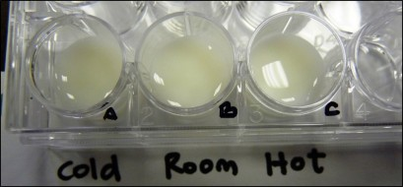 Figure 8. Labels for 24-well plate.

Procedure (Preparing to Measure Temperature Effects)
- Use the thermometer to measure the temperature of the “room temperature” lactase sample and record this temperature in Data Table 2.
- Use the thermometer to measure the temperature of the boiling water and record in Data Table 2.
- Remove the lactase from the freezer and use the thermometer to measure the temperature of the cold lactase. Record the temperature in Data Table 2.
- Label a clean pipet “cold,” and use it to transfer 10 drops of the cold lactase into Well A.
- Label a clean pipet “room,” and use it to transfer 10 drops of the room temperature lactase into Well B.
- Label a clean pipet “hot,” and use it to transfer 10 drops of the hot temperature lactase into Well C.
Note: There will be pressure in the hot pipet as a result of the temperature difference of the air in the pipet and the hot lactase. Allow the pipet to release some of the hot lactase before adding the drops to Well C.

Procedure (Measuring Temperature Effects)
- Set the watch or timer for 5 minutes.
- During the 5 minutes, extinguish the burner by carefully placing the lid of the burner over the flame. Do not tighten the lid onto the burner until it is completely cooled.
- After the 5 minutes have passed, insert the green side of a fresh glucose strip into Well A, stirring the solution in the well with the strip for approximately 5 seconds.
- After 5 seconds, remove the strip from the well and place it onto the paper towel.
- Use the Glucose Color Chart to determine the amount of glucose present (mmol/L) in the well. Read the test strip 15-30 seconds after removing it from the well.
- Record the amount of glucose present in Data Table 2 in the “Cold” column under “Glucose Concentration” for 5 minutes.
- Repeat step 18 through 21 for the remaining two wells at 5 minutes.
- Take additional glucose readings for each of the wells at 10 minutes, 15 minutes, and 20 minutes, recording the glucose concentration for each time and well in Data Table 2.
- Discard the used glucose strips in the trash when complete. Keep all solutions and other materials to use in the next steps.
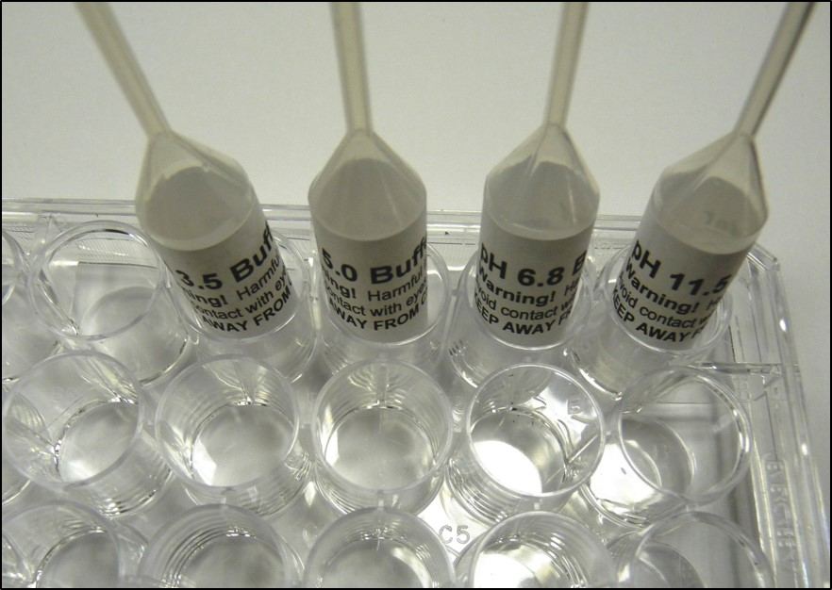 Figure 9. pH set up.

Procedure (Sample Prep for pH Effects)
- Put on your safety glasses and gloves.
- Use the permanent marker to label 4 empty wells in the 24-well plate “1, 2, 3, and 4.”
- Use the scissors to cut off the tip of the pH 3.5, pH 5.0, pH 6.8, and pH 11.5 pipets. Place each pipet bulb side down (tip side up) in empty wells of the 24-well plate, using the well-plate as a pipet holder. See Figure 9.
- As described in Data Table 3, use the pH pipets, and labeled pipets, to add the following solutions into the following wells:
  - In Well 1: add 3 drops of pH 3.5 buffer, 2 drops of lactase, and then 2 drops of milk
  - In Well 2: add 3 drops of pH 5.0 buffer, 2 drops of lactase, and then 2 drops of milk
  - In Well 3: add 3 drops of pH 6.8 buffer, 2 drops of lactase, and then 2 drops of milk
  - In Well 4: add 3 drops of pH 11.5 buffer, 2 drops of lactase, and then 2 drops of milk
Note: Ensure that pipets are only used to transfer solutions from their designated cups.

Procedure (Measuring pH Effects)
- Allow each of the reactions to occur for 10 minutes.
- After 10 minutes, pick up a fresh glucose strip and insert it into the reaction in Well 1. Keep the strip in the solution for 5 seconds.
- After 5 seconds, remove the strip from the well and place it onto the paper towel.
- Use the Glucose Color Chart to determine the amount of glucose present (mmol/L) in the well. Read the test strip 1 minute after removing it from the well.
- Record the amount of glucose present in Data Table 3 under “Glucose Concentration.”
- Repeat steps 2 through 5 for the remaining three wells (2, 3, and 4).

Cleanup:
- Discard the used glucose strips in trash when complete.
- Pour all remaining solutions down the drain with ample amounts of water.
- Use the dish soap and brush to wash all remaining well plates and glassware.
- Return all items to the lab kit for future use.

